Julio Barros
Explain why either hping3 or HOIC have legitimate uses for offensive security? Give examples.
Hping3: Primarily a network tool for crafting and sending custom TCP/IP packets, it is used in network security auditing, penetration testing, and network performance testing. It helps in identifying vulnerabilities, testing network defenses, and assessing how systems handle various network conditions.
HOIC: Known for its capacity to generate significant load on web servers, it's utilized in stress testing and DDoS mitigation testing. It allows organizations to evaluate the resilience of web applications under heavy traffic and the effectiveness of their DDoS countermeasures.
Both tools are also valuable in educational contexts for teaching cybersecurity concepts. Their use should always be ethical, legal, and with explicit permission to avoid legal and ethical issues.
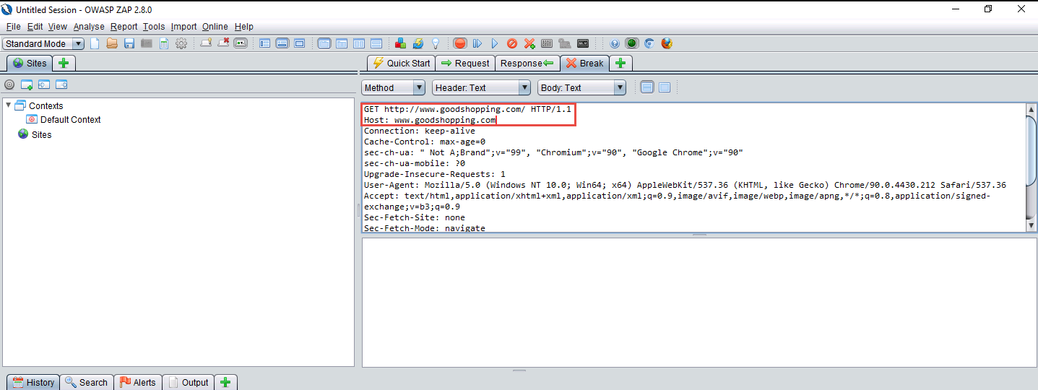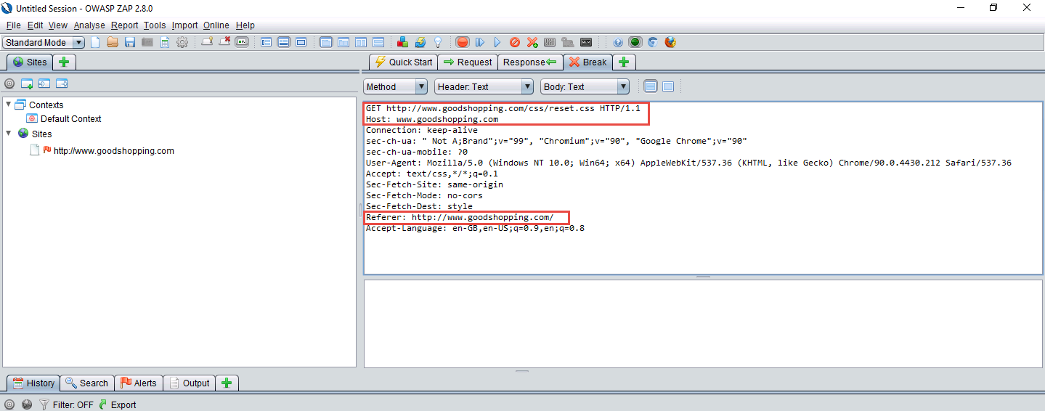

- What worked well in the lab?
Part 2,3,4,5 was working perfectly, when I got to part 6 the stop working at all, I tried multiple times and multiple ways to reconnect but nothing worked at all. I will be posting down all my screenshots trying to reconnect to the server.
- What parts were troublesome?
After part 6 on the lab I was not able to have access and complete the assignment.
- Over all impression of the lab?
This was the first lab I had a bad experience for multiple days, I tried different hours, and nothing helped. I really enjoyed creating the hping3 and HOIC attacks, but I was not able to complete the Zed Attack Proxy, because the lab kept crashing.




